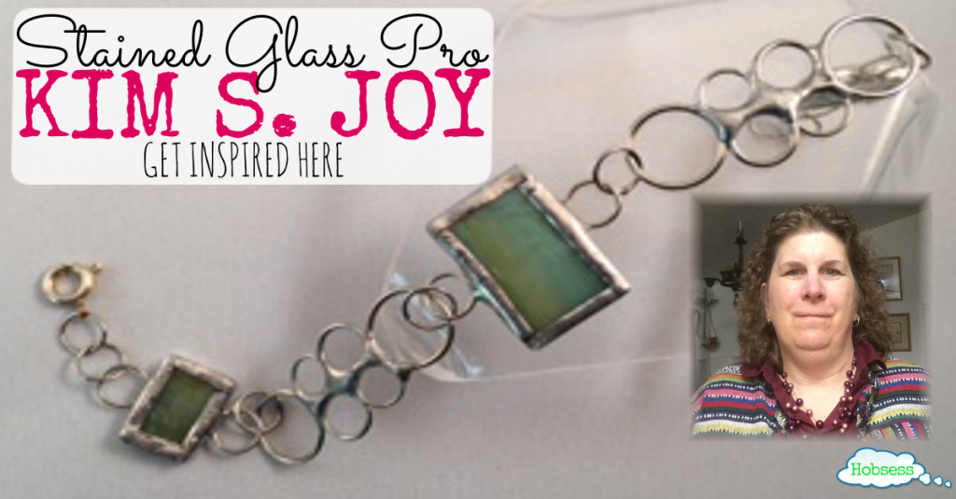
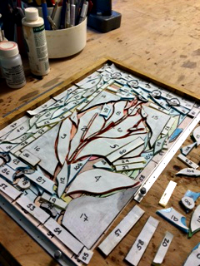
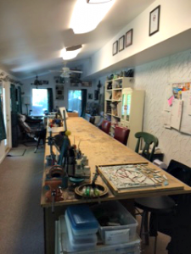
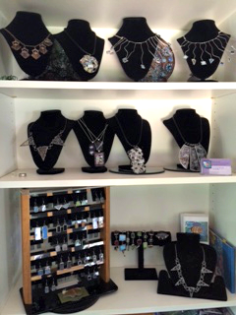

Interview by Rev of www.hobsess.com/meet-kim-s-joy-stained-glass-expert You can read the article on Rev's site by following the link.
Meet Kim S. Joy: Stained Glass Expert
June 21, 2016 By Rev
I have always had an appreciation of art. Maybe, I should rephrase.
I have always had an appreciation for artists.
I find great beauty in the creation of individuals. We were born to create and create is what we should do.
Not only to leave your mark on the world but as a means to express your essence, being, attitude, feelings. You know. Express you.
I appreciate artists also because I want to be an artist.
Artists are brave and create what they love without care or concern of what other people think. I love that spirit.
I want to introduce you to a stained glass artist that I admire.
Her name is Kim S. Joy. What a great name!
And I’m sure after you read her interview, you will find your own joy. 🙂
Learn From Kim S. Joy, Stained Glass Expert
What hobby are you good at?
My passion is stained glass.
I love the play of light on colored, textured glass.
Many times I think I will use a particular sheet of glass for a project only to have the glass tell me where it is really needed.
No, it does not “talk” to me but I can feel it.
How long have you been doing it and why did you start? What got you interested?
I have been making stained glass creations since 1982 and added jewelry to my workbench in 2000.
I started stained glass as a way to make money and be independent.
My cousin did church window repairs in New England in the 1970s and I always thought that would be a cool thing to do.
What are the benefits for you? What do you get out of it? Why is this your passion?
Benefits are creative outlet and creative freedom along with the love I feel for my craft.
I am able to work when I want and where I want.
Stained glass is part of my life and lifestyle.
I can not imagine my life without stained glass in it.
My biggest fear is losing my sight and never seeing the colors of glass that I have been working with.
How did you get good at it?
It has taken me years to get to the point where I am.
I apprenticed under a stained glass artist that has now retired.
My students are amazed by the way the glass breaks for me, not realizing that it took years to master cutting and breaking glass.
I challenge myself to push the limits with flat glass.
It is not your Grandmother’s church windows anymore, you are only limited by your imagination.
What advice would you give to beginners? What shortcuts or secrets can you share?
Take it slowly.
Take classes from different instructors, learn different ways to do the same thing.
Apprentice if you can, teach under a master if possible before going out into the world to teach.
To learn you must be willing to teach.
Are you a member of any local or national organization/club related to your hobby? If yes, please share the name and benefits of belonging.
NCAGG (National Capital Art Glass Guild) – being able to network with other glass artists in all glass mediums.
SGAA (Stained Glass Association of America)– a national association with glass artists from all over the US.
PMC Guild (Precious Metal Clay) – I have been working with PMC since 2006 and the community is awesome

If you happen to make money from your interest, do you have a website, Etsy store, Facebook page, other social media, that you would like to share?
Website – http://www.kimsjoy.com
Etsy – https://www.etsy.com/shop/kimsjoy
Facebook – https://www.facebook.com/kimsjoystainedglass/
Pinterest – https://www.pinterest.com/kimsjoyglass
Twitter – https://twitter.com/kimsjoyglass
Any other information that you would like to share?
Thank you for the opportunity to share a little of my story with your readers.
If anyone would like more information on stained glass, please feel free to contact me.
Connect with Kim
Be sure and visit Kim’s website at kimsjoy.com to learn more about her collection of stained glass projects including jewelry. She also teaches classes so if you are in the D.C./Virginia area, you can attend.
Also, visit her KimSJoy Etsy store and prepare to be amazed at her talent.
If you are looking for the perfect gift, you just might find it here.
Looking at her work and workspace, it is easy to see how Kim became a stained glass expert.
Meet her (Facebook, Twitter, and/or Pinterest) connect with her, support her. 🙂
Be Like Kim
Just as Kim has turned her love of stained glass into a profitable business, so can you.
There is absolutely nothing that can stop you from pursuing your passion – except you.
If you are interested in pursuing stained glass as a hobby or even as a way to profit, check out our Stained Glass Hobby Page and get started learning. Then, you can become a stained glass expert.
What did you like most about Kim’s story? Would you ever try making stained glass projects?

Kim S Joy Receives 2014 Best of Woodbridge Award
​
Woodbridge Award Program Honors the Achievement
WOODBRIDGE August 7, 2014 -- Kim S Joy has been selected for the 2014 Best of Woodbridge Award in the Jewelry Repair category by the Woodbridge Award Program.
Each year, the Woodbridge Award Program identifies companies that we believe have achieved exceptional marketing success in their local community and business category. These are local companies that enhance the positive image of small business through service to their customers and our community. These exceptional companies help make the Woodbridge area a great place to live, work and play.
Various sources of information were gathered and analyzed to choose the winners in each category. The 2014 Woodbridge Award Program focuses on quality, not quantity. Winners are determined based on the information gathered both internally by the Woodbridge Award Program and data provided by third parties.
About Woodbridge Award Program
The Woodbridge Award Program is an annual awards program honoring the achievements and accomplishments of local businesses throughout the Woodbridge area. Recognition is given to those companies that have shown the ability to use their best practices and implemented programs to generate competitive advantages and long-term value.
The Woodbridge Award Program was established to recognize the best of local businesses in our community. Our organization works exclusively with local business owners, trade groups, professional associations and other business advertising and marketing groups. Our mission is to recognize the small business community's contributions to the U.S. economy.
SOURCE: Woodbridge Award Program

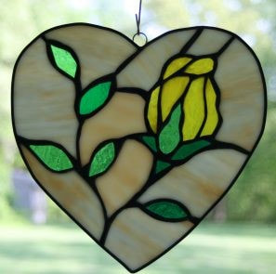
February 21, 2011 I was featured in an article in the Lorton Patch, click here to see the article or read it below.
​Workhouse Artist of the Week: Kim S. Joy
Stained Glass: Flowers in February
Posted by Susan Francis , February 21, 2011 at 04:48 AM
When Kim S. Joy learned she’d be the Workhouse Building 9 featured artist in February, she decided her show’s theme would be flowers. “I’m not a real fan of flowers,” she said. “But I thought I’d push myself to overcome that resistance, and bring something bright and cheery into the cold winter.”
Joy’s stained glass exhibitionFlowers in February includes free-standing, three dimensional objects; plant pokies, a flower on a long rod to us in a garden or a planter; and single flower sun catchers that hang in a window. “I’m going to start the show with about two dozen pieces and continue to add more during the month.” said Joy.
Joy works from photographs, drawings, architectural elements, tiles, and even coloring books. She projects a pattern onto a wall where she’s hung paper, then traces it. “I use pencil first, then trace over it with a Sharpie,” she said. She then lays the pattern on the glass.
“I love making larger pieces because they take more time,” said Joy. She said that her process of creating depends on how she feels that day. “If I feel adventurous, I will try new colors,” she said. “Colors dictate what I make.”
Her favorite piece in Flowers in February is a pink flower influenced by Charles Rennie Mackintosh, the Glasgow born architect, designer and artist. “It’s a very pale pink and very pale green contemporary piece with clean lines” she said.
As a child, Joy loved creating art, but says she can’t draw to save her life. “I always worked with found objects like little sticks and pine cones, which I strung together into necklaces,” she said. She also enjoyed working with wood, creating three dimensional objects.
In 1982, Joy took a stained glass class and loved it. She was married to a man in the air force, and their travels forced her to try other art, too. “When we lived in Hawaii it was too expensive to have glass shipped to the Islands, so I took classes in jewelry and weaving,” she said. Joy continues to work in these mediums today, but they aren’t her preferred medium. “My first love is stained glass,” she said.
In addition to crafting stained glass, Joy also repairs it. “I’ve repaired some very interesting pieces that people bought in Europe and shipped back to the States,” she said. One was a church window she believes came from Belgium. “It was three feet wide and six feet long, packed for shipping with a painting behind it,” she said. The screw eyes from the frame broke pieces of the glass. “As I worked, it was interesting to consider who may have made it and how it came to be in my hands,” she said.
When making repairs, Joy looks for old glass to use in order to preserve the integrity of the window. “I keep old glass I’ve collected separated in a case,” she said. Often she obtains old glass from stained glass artists who are retiring and want to sell their supply. “A man in his 80s who had worked in stained glass for 40 years sold me his glass,” she said.
Joy says that she’s carrying on the artistic tradition of her family. “When I was younger I had a cousin who drove around in a van with a generator and repaired church windows,” she said. Also, her dad was a woodworker, and her great-great-grandfather was a painter in Scotland.
In addition to creating, Joy teaches jewelry making and stained glass with Arlington and Fairfax County adult education, at Fort Belvoir, and at the Workhouse Arts Center.
All of which might imply that Joy is a 9 to 5 person. She isn’t. “I believe you’re most alive when you want to learn and experience everything,” she said. “Even if you fail at something new, it builds who you are.”

